

**Effervescence Tasmania 2019**

**~ Josef Chromy Winery, Tamar Valley ~**

**15 – 17 November 2019**

Dear Friends and fellow Champagne Goddesses / Gods 😉

I want to tell you about this year’s Effervescence Tasmania Festival, celebrating Tasmania’s Sparkling Wine.

Tickets to the renowned Effervescence Tasmania will be released for sale on 1 July 2019… and I fear they will sell-out in 24 hours (as they did in 2018)

While I work on the final inclusions of the C***hampagne Goddess Tour*** to this magical festival of Tasmanian Sparkling Wine… the best way for me to secure your tickets to the most exciting Effervescence Sparkling Wine and Champagne Masterclasses; dinners and touring options is to take a (refundable) deposit from you. With plenty of time to change your mind, invite additional friends and modify your plans, at least we won’t miss out on a spot!

Secure your place on the Champagne Goddess Tour to [Effervescence Tasmania](http://www.effervescencetasmania.com) 2019

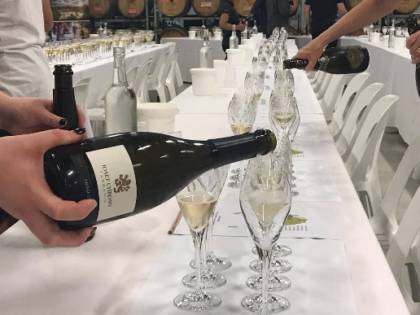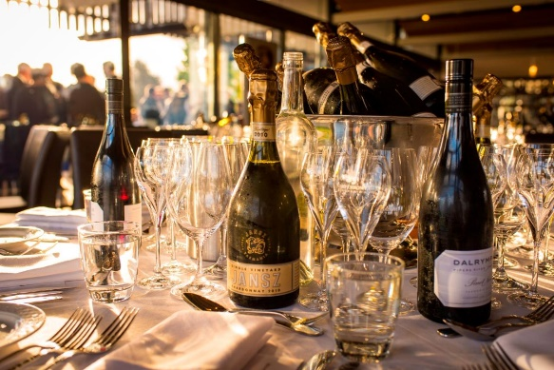****Fill-in this form, return it with your deposit, and we will ensure you don’t miss out.

Here’s what we’re planning for the weekend. [Final costs will be communicated by mid-July 2019.]

* 2 nights luxury Accommodation – Single, Twin or King rooms available
* Friday evening choice of
  + - Black-tie Degustation Dinner at Josef Chromy Winery (limited to 8 guests)
    - Celebration of Tasmanian Sparkling wine Dinner with Loic Le Calvez, Winemaker + Oenologist
* Unlimited Tastings and three Masterclasses at Saturday’s Effervescence Festival
  + - Tyson Stelzer’s Tasmania vs the Rest-of-the-World, or
    - Nick Haddow’s Bruny Island Cheese Tasting class. (*2019 program still to be confirmed)
* Exclusive, private dinner with a leading Tasmanian Winemaker (Last year we hosted Natalie Fryar, one of Australia’s most decorated Sparkling Wine makers, and the creator of BelleBonne Sparkling)
* Partner program: Golf, Fishing and additional Wine-tasting options available
* Transfers to / from Launceston Airport, Josef Chromy Winery, Dinner venues and partner options.

**Final Tour inclusions will be confirmed by 12 July 2019.**

**Secure your place in this year’s personalised Champagne Goddess Tour, by returning this form by 24 June 2019 with a fully refundable* Deposit of $500 AUD.**

**Effervescence Tasmania 2019**

**~ Josef Chromy Winery, Tamar Valley ~**

**15 – 17 November 2019**

**To express your interest:**

Complete the following details, and EFT the $500 *refundable deposit to Susan Le Roux by 24 June 2019

*Tour Inclusions will be confirmed once the Effervescence Tasmania Official Program has been finalised.*

|  |  |
| --- | --- |
| **GUEST #1**  **First Name:**  **Surname:**  **Preferred First: Name:** | |
| **GUEST #2 - TWIN SHARE or KING ROOM – please circle**  **First Name: Surname:**  **Preferred First Name:** | |
| **Email address for updates:** | **Mobile Phone:** |
| **EMERGENCY CONTACT WHILST YOU ARE AWAY:**  **Name:**  **Relationship:**  **Mobile:** | |
| **Note**: ∘ All components of the Effervescence Tasmania 2019 Festival are still to be confirmed. The Champagne Goddess Tour will be priced according to private and public experiences, Master-classes and unique tour inclusions. These will be subject to availability, and offered in a separate document.  **Not included:** ∘ Flights to and from Launceston. ∘ Travel insurance; ∘ Snacks at the Harvest Market, Saturday; ∘ Individual Transfers | |
| **\*Cancellation Policy:**  $500 AUD inc GST Deposit:   * 100% refundable to 30 July 2019 * 50% refundable from 31 July to 31 August 2019 to * 0% refundable after 1 September 2019   **Final Payment of the difference in tour costs, less deposit, required by 1 October 2019.** | |
| **\*Refundable deposit of $500.00 per person.**  **ANZ BANK**  **SUSAN LE ROUX – CHAMPAGNE GODDESS**  **BSB:** 012390 **ACCT:** 309833502 | |