

Sparkling Wine + Dark Mofo Tour 2025
Tamar Valley + Hobart, 5 - 9 June, 2025
~ incorporating DARK MOFO and MONA, over the King’s Birthday Long Weekend ~

Dear Champagne and Sparkling Wine connoisseurs..
Join me for the experience of a lifetime: a bespoke, private tour of the best that Tasmania has to offer…
The unique sparkling wines of the Tamar and Coal Valleys PLUS Tasmania’s best-kept winter-secret: DARK MOFO…
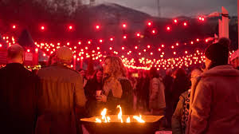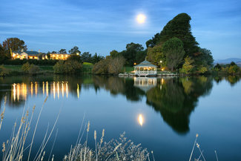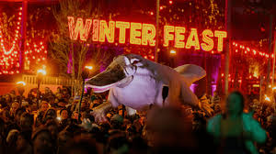
Explore Tasmania's Sparkling Elegance and Dark Mofo Mystique – June 2025
Prepare for an unforgettable journey, blending Tasmania’s finest sparkling wines with the enchanting allure of Hobart’s renowned Dark Mofo festival. From luxurious accommodations to breathtaking natural landscapes, indulge in exceptional winery tours guided by industry icons, such as Andrew Pirie at Apogee and Natalie Fryar at Bellebonne. Savor gourmet experiences, discover sparkling wine artistry, and even master "The Art of Sabrage."
Wind your way from the lush Tamar Valley to Hobart’s cultural heartbeat, relishing the enigmatic experiences of Dark Mofo: the electrifying Winter Feast, a private MONA adventure with wine tasting, and world-class music under winter-sunny skies. Thoughtfully curated to captivate all your senses, this tour promises camaraderie, charm, and unparalleled memories.
Take advantage of the Early Pricing: special rate of $3,490 per person until 12 May 2025
Please fill-in page 2, scan + return, pay the deposit, and I will ensure the fun begins!
Inclusions:
- Arrival + departure airport transfers.
- 2 nights funky accommodation at the brand new ‘Change Overnight Philanthropic Apartments’ in Launceston – a 3-bedroon penthouse apartment, King or Twin rooms available. Single rooms available on application.
- 2 nights elegant accommodation at The Lenna of Hobart boutique hotel, Battery Point, Hobart.
- Thursday, Friday and Saturday full-days of sparkling (and still) wine experiences, a walking tour to Cataract Gorge, light lunches, shared dinners and some free-time.
- Visits to Tamar Valley wineries, with private, unique sparkling wine-tasting experiences at:
  - An exclusive, private dinner with the amazing Natalie Fryar - one of Australia’s most decorated sparkling wine makers of BelleBonne sparkling wines: Dinner at Evenfall restaurant.
  - Andrew Pirie – considered ‘the pioneer of the Tasmanian Wine industry’ and his winery Apogee;
  - Winemaker Fran Austin’s Delamere Vineyard, with her husband Shane Holloway;
  - Ed Carr’s House of Arras cellar door experience: their 90 minute ‘Sparkling Masterclass’
  - Stefano Lubiana in Hobart; Morilla Estate wine tasting at MONA, and more….
- a free evening Friday night; and a stroll around Launceston’s Harvest Markets on Saturday.
- Drive to Freycinet National Park and Wineglass bay; and onward to Stefano Lubiana’s cellar door
PLUS: incredible Dark Mofo experiences:

  - Saturday 7 June - The Winter Feast: Dark Mofo’s showcase of sumptuous Tasmanian produce paired with exceptional still and sparkling Tassie Wines… housed under cover on Hobart’s Constitution Dock, you’ll get to taste your way around the venue at your leisure.
  - Sunday 8 June – return ‘posh pit’ transfers to the unique island peninsula for MONA’s Dark Mofo extravaganza, art and special exhibitions
  - Morilla Wines – tasting ; plus Dark Mofo music on the lawns…
  - Option to return to Dark Mofo’s Winter Feast with open fires and whisky tastings upon our return
- The whole tour includes luxury private transport – driven by Susan Le Roux; Arrival and departure transfers to/from Launceston + Hobart Airports; Winery Touring Thursday, Friday + Saturday; ‘Posh Pit’ canapes and sparkling wine transfers to MONA; and guided walks around Hobart.

Secure your place in this year’s ‘Goddess Tour of Dark Mofo, Tasmania’ by returning the Page 2 form – also downloadable- by 28 May 2025 with a refundable* deposit of $1,000 AUD.

After 12 May 2025, per person price will be $3,990pp

